SOFTWARE ENGINEERING SETUP PROCEDURES

**A. GIT HUB SETUP**

1. Visit github.com
2. Click `signup for Github`



1. Enter email

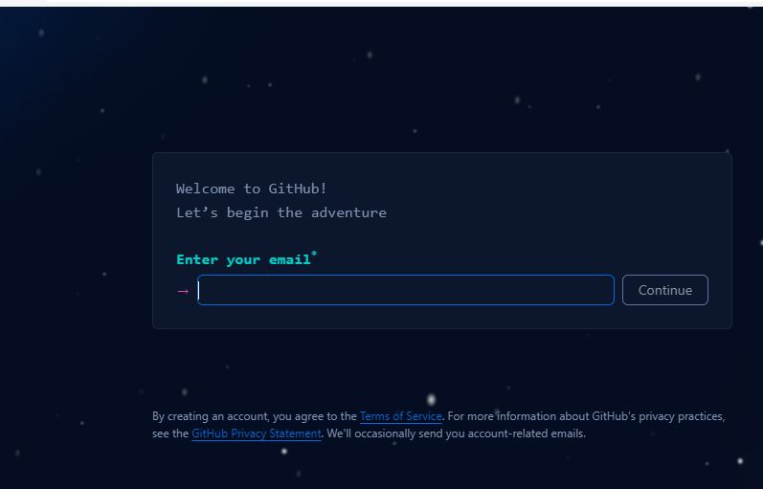

1. Enter your password

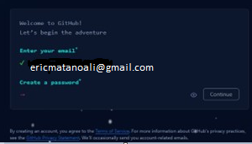

1. Enter your username

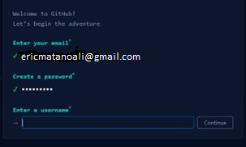

1. Click continue

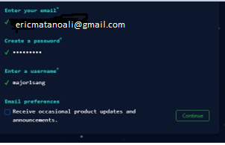

1. Verify your account

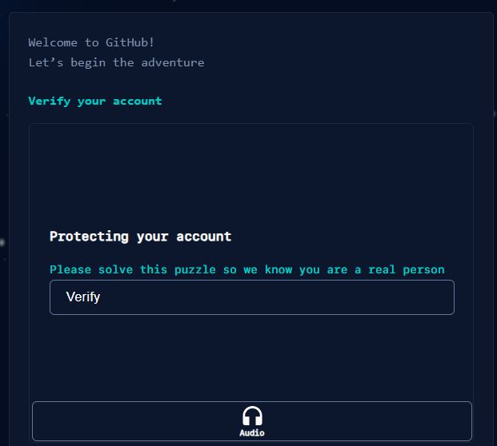

1. Enter code sent via email to cornfirm

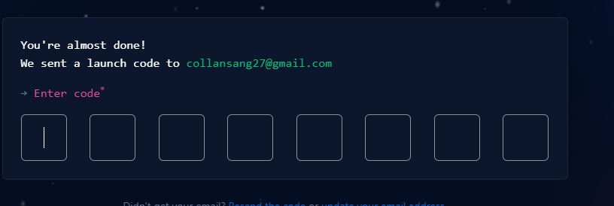

**VISUAL STUDIO CDE SETUP PROCEDURE**

1. visit <https://code.visualstudio.com/Download>
2. click download for windows
3. open in downloads and click the install icon to start the installation process
4. accept terms and conditions
5. create a desktop icon and click next
6. Click Install and wait to complete the installation process
7. launch and download some extensions such as code runner, Live Preview, dart, flutter, etc
8. 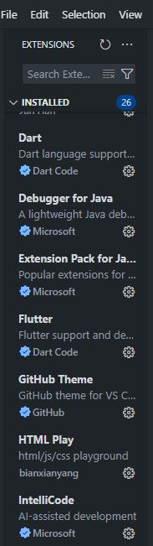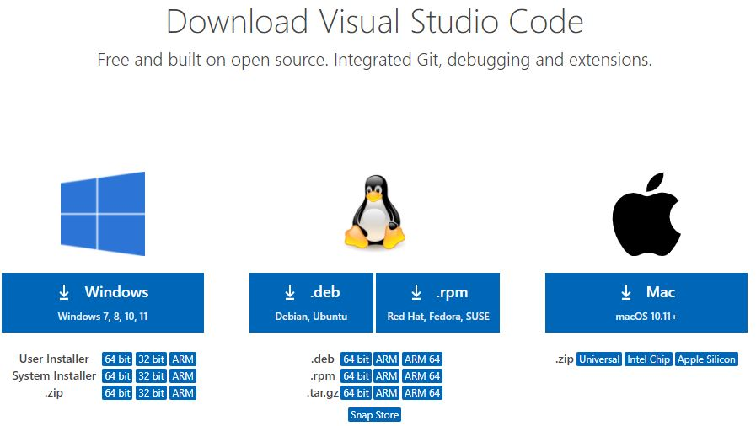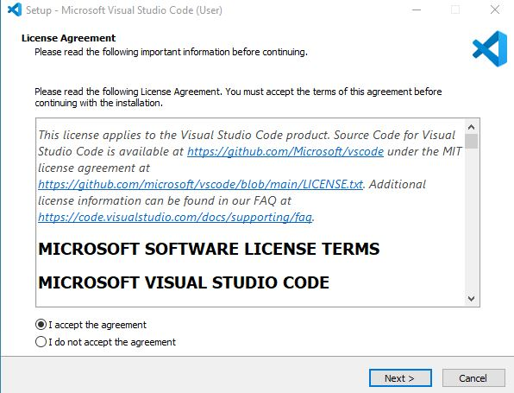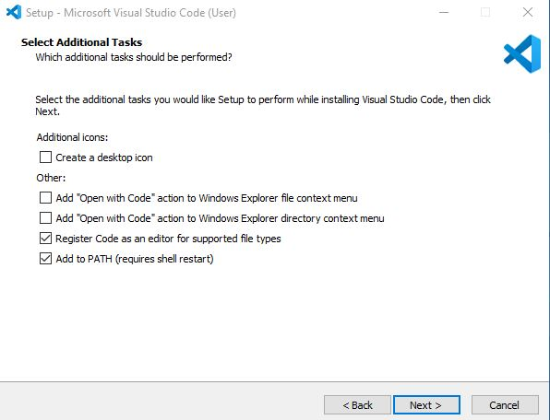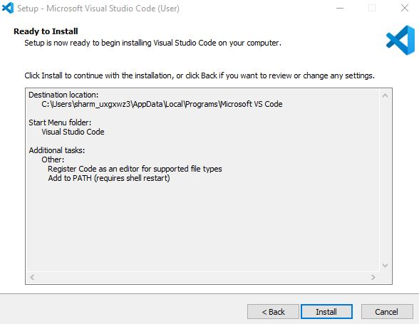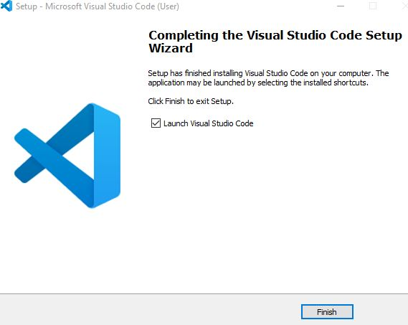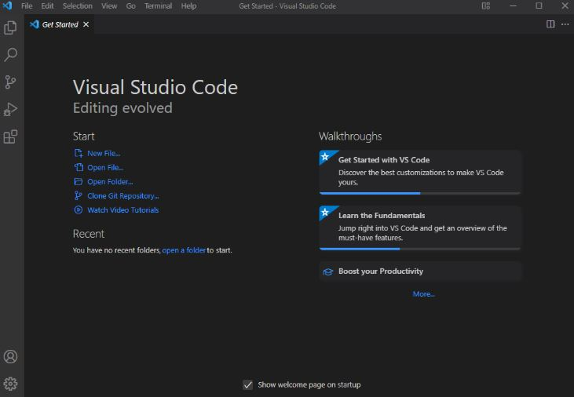

**python installation process**

1. visit http://wwww.python.org
2. download the Windows installer (64-bit) (for my ase)
3. locate in your downloads and open to install
4. check the two boxes and click Install now
5. after successful installation confirm the version on git bash by running the (python --version) command
6. install pip and confirm version on git bash

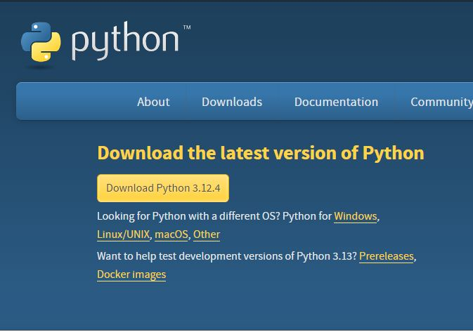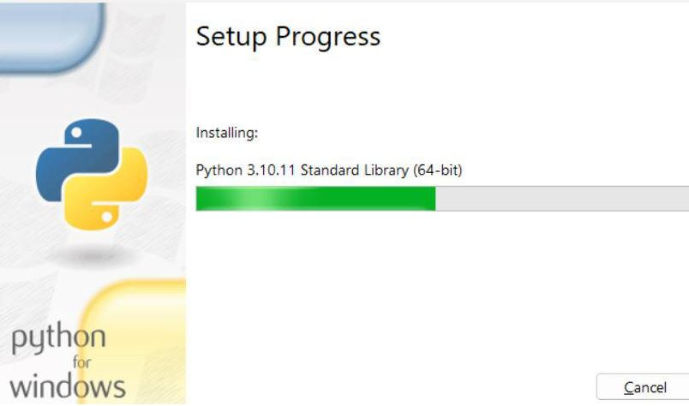

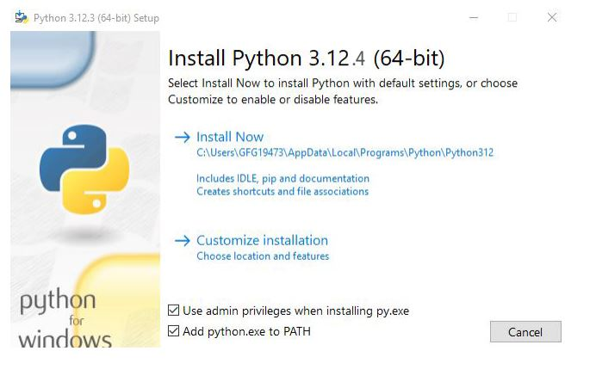

**MYSQL installation**

1. Visit dev.mysql.com/downloads/installer.
2. Download the second one.
3. Open to configure.
4. Allow the computer to be altered.
5. Allow the app to make changes.
6. It will open an interface.
7. Choose server only.
8. Execute.
9. Next to configuration.
10. Choose a standalone mysql server.
11. Choose development comp.
12. Check the last dots.
13. Type and network
14. Check the last pot
15. Authentication method, go with default.
16. Create a password.
17. go to community download ad download server, shell and workbench
18. finish to update.
19. Windows service, check the first three dots

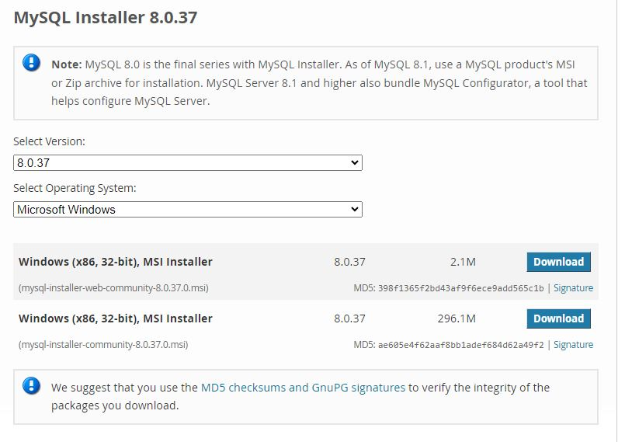

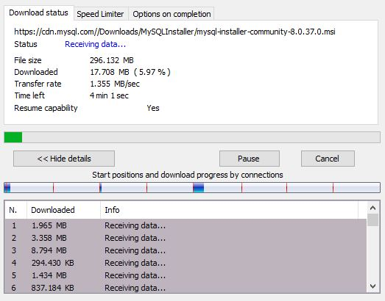

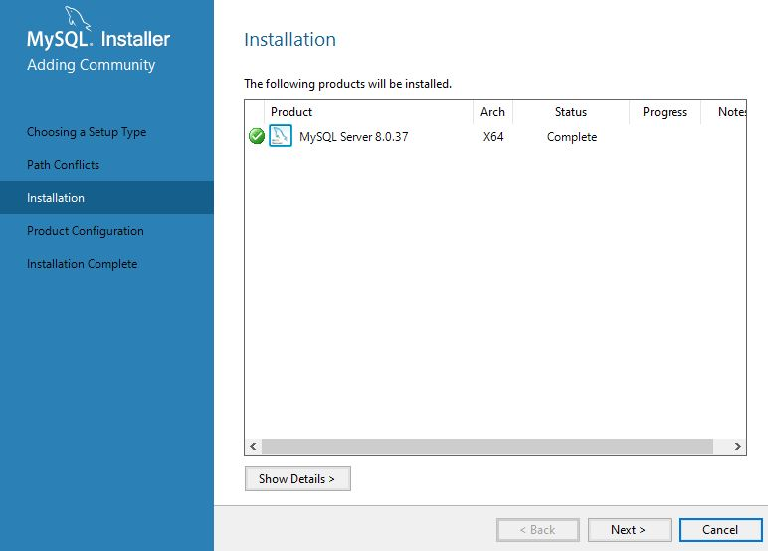

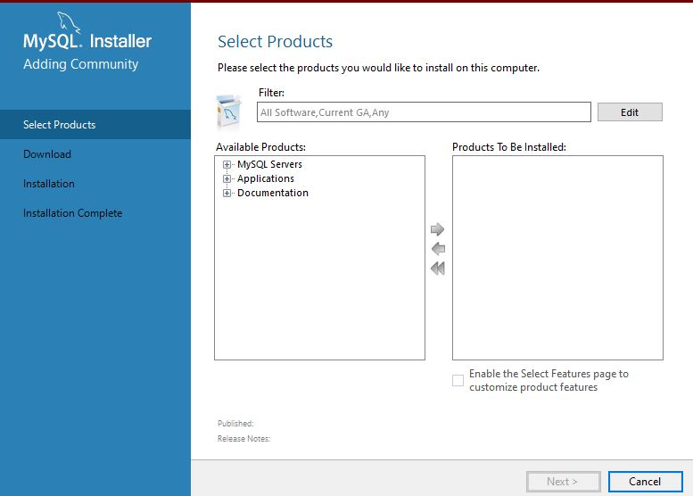

**WINDOWS 11 INSTALLATION**

1. Go to https://www.microsoft.com/en-us/software-download/windows11 and look for the section called Create Windows 11 Installation Media. Click the Download Now button that's under it.
2. Once the file finishes downloading, run it and click **Accept**
3. You'll be asked to choose the language you want Windows 11 to be in. By default, it will match your current system, but you can change it if you need to. Click **Next**
4. Installation media can either be an ISO file or a flash drive, but only the flash drive will work if you're using a new PC. Select **USB flash drive** and click **Next.**
5. Windows 11 will begin downloading and files will be transferred to your flash drive. Once it's done, your flash drive will be ready to be used as installation media.

